**Software Requirements Specification**

**for**

**Trader Evaluation System 1.0**

**Version 0.3**

**Prepared by <Mengyao Wang, Teng Tang, Ashish Tripathi, Josiah Tolento>**

**<INFO 3150 – Object Oriented Software Engineering>**

**<Mar 26, 2019>**

**Table of Contents**

**1.0 Introduction** **4**

**1.1 Purpose** **4**

**1.2 Document Conventions** **4**

**1.3 Intended Audience** **4**

**1.4 Product Scope** **4**

**1.6 References** **5**

**2.0 Overall Description** **6**

**2.1 Product Perspective** **6**

**2.2 Product Functions** **6**

**2.3 User Classes and Characteristics** **6**

**2.4 Operating Environment** **6**

**2.5 Design and Implementation Constraints** **6**

**2.6 User Documentation** **7**

**2.7 Assumptions and Dependencies** **7**

**3.0 External Interface Requirements** **7**

**3.1 User Interfaces** **7**

**3.2 Hardware Interfaces** **7**

**3.3 Software Interfaces** **7**

**3.4 Communications Interfaces** **7**

**4.0 Requirement Specifications** **7**

**4.1 Description / Use Case Diagram** **7**

**4.2 Functional Requirements** **8**

**4.3 Nonfunctional Requirements** **9**

**4.3.1 Compatibility Requirements** **9**

**4.3.2 Security Requirements** **9**

**4.3.3 Business Rules** **9**

**Revision History**

|  |  |  |  |
| --- | --- | --- | --- |
| **Name** | **Date** | **Reason For Changes** | **Version** |
| Mengyao Wang | 02/16/2019 | Initial draft. | 0.1 |
| Teng Tang | 02/19/2019 | Added functional requirements, changed Use Case Diagram | 0.2 |
| Mengyao Wang | 03/24/2019 | Applied requirements change | 0.3 |

## 1.0 Introduction

### 1.1 Purpose

This document describes the functional and non-functional requirements for the Trader Evaluation System 1.0. Trader Evaluation System allows HR staff of the trading company to track and evaluate the trader staff’s performance. Also, the system allows Finance department to generate company’s monthly and yearly financial reports and traders’ monthly commission. Analysis team can use the system to analyze the stock trend. Administrator will manage all the users’ data.

### 1.2 Document Conventions

No document conventions are being used at this time.

### 1.3 Intended Audience

This document is intended to be used by members of the project team and the instructor of the course.

### 1.4 Product Scope

Trader Evaluation System is a web-based application that allows HR staff of a trading company which trade in North American stock market (NA) to evaluate each trader’s performance based on the winning rate of their trading records. It allows trader users to upload their trading records, then the HR users can use the records to evaluate the traders, finance department can use the record to generate company’s monthly and yearly financial reports and traders’ monthly commission, and analysis team can use to analyze the trend of stocks in given period. All the users’ data will be managed by administrator. The system is easy to use, it can support all major browsers.

**1.5 Glossary**

|  |  |
| --- | --- |
| **Term** | **Definition** |
| trader employee | the employee who trades stocks in the stock market on behalf of the company |
| HR employee | the employee in the Human Resource Department of the company |
| Analysis team | the employee who use history data of system to analyze the trend of stocks in a given period. |
| Finance department | the employee who use trading record to generate company’s monthly and yearly financial reports and traders’ monthly commission. |
| administrator | the user who holds full control of the system and the database |
| trading record | information that records the stock transaction history of the trader employee, generated by a third party application |

### 

### 1.6 References

https://web.cs.dal.ca/~hawkey/3130/srs_template-ieee.doc

https://www.bmc.com/blogs/software-requirements-specification-how-to-write-srs-with-examples

https://www.lucidchart.com/pages/uml-use-case-diagram?a=1

## 2.0 Overall Description

### 2.1 Product Perspective

Trader Evaluation System is a web-based system for a stock trading company to evaluates trader employees’ performance based on their trading records. The system consists of two parts: the database and the web page. Users interacts with the system through the web page interface, records are saved to the database.

### 2.2 Product Functions

* allows users to create accounts
* allows users login
* allows trader employee to upload trading records
* saves records in database
* allows users to review records and history data
* queries database to calculate earnings
* allows user to review results
* queries database to analyze stock trend
* queries database to generate company’s monthly and yearly financial reports
* queries database to generate every trader’s monthly commission

### 2.3 User Classes and Characteristics

1. trader employee: the user that can only upload and view its own record
2. HR employee: the user that can view all the records, submit calculation queries to the database and view the results
3. administrator: the user who has full control of the system and the database, this user also approves the privileged accounts for users
4. Finance department employee: the user that can view all the records, submit queries of financial reports and traders’ commission to the database and view the result.
5. Analysis team: the user that can view the history data, analyze the stock trend and get stock price of a given period.

### 2.4 Operating Environment

The front end of the system supports major browsers in major platforms. The back end of the system requires a PHP web server and a MySQL database server.

### 2.5 Design and Implementation Constraints

1. Trader employees should have their trading records generated by a third-party application
2. Trading records format and the importing function of this system have to be compatible, changing of records format can lead to errors
3. Connection to the database server has to be reliable

### 2.6 User Documentation

No user documentation information at this time.

### 2.7 Assumptions and Dependencies

It is assumed that each trader employee uses a unified compatible application to track and generate the stock trading record. Each employee is responsible for the correctness of its own record.

## 3.0 External Interface Requirements

### 3.1 User Interfaces

The system contains:

* a web page that allows user to login or register account
* a web page that allows user to retrieve account password
* a web page that allows user to upload trading record
* a web page that allows user to review trading record
* a web page that allows user to submit calculation queries and displays the calculation result
* a web page that allows user to submit stock trend analysis queries and be able to do jobs such as get the specific price of stock in a given period
* a web page that allows user to submit queries of company’s monthly and yearly financial report and every trader’s monthly commission

### 3.2 Hardware Interfaces

No specific hardware interface is used.

### 3.3 Software Interfaces

Database server: MySQL 6.0 or newer version

Web server: PHP 7.0 or newer version

### 3.4 Communications Interfaces

Users access the web pages of the system through LAN or Internet connection. SSL is used to secure the connection. The web server and database are also connected with SSL.

## 4.0 Requirement Specifications

### 4.1 Description / Use Case Diagram

Trader employees of the company login to the system with their own accounts and upload their trading records (generated by third party applications), HR employees login to the system to view the records and let the system evaluate trader employees’ performance by calculating earnings. The system can display traders’ record and the evaluation result. Finance department users login to the system and view the trading record, then generate the company’s monthly and yearly financial reports and every tarder’s commission on monthly base. Analyst can also login and view the history data from database, and then use the data to analyze the period trend of the stocks

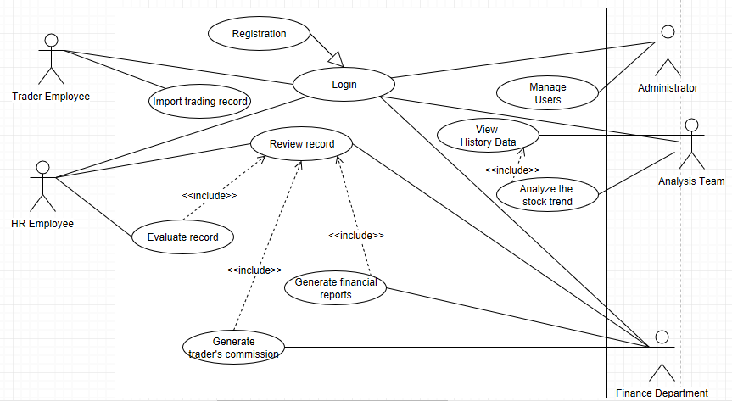

### 4.2 Functional Requirements

REQ-1: the system uses SSL connection with the database server and users

REQ-2: users can create accounts and log in to the system

REQ-3: normal accounts have low privilege, higher privilege accounts have to be approved by system administrator

REQ-4: the system accepts trading data import from trader employee

REQ-5: data are stored in a database

REQ-6: the system can display the record, normal accounts can view their own data, higher privilege accounts can view all the data

REQ-7: the system can send queries to let the database calculate the winning rate of each trader, and then display the result

REQ-8: the system can send queries to let the database show the history data and the stock trend analysis result

REQ-7: the system can send queries to let the database generate the financial reports and trader’s commission

**4.3 Nonfunctional Requirements**

#### 4.3.1 Compatibility Requirements

REQ-1: The web pages of the system support all major browsers.

#### 4.3.2 Security Requirements

REQ-1: Passwords of user accounts are encrypted.

REQ-2: Connection to database server is secured with SSL.

REQ-3: Connection from WAN user is secured with SSL.

REQ-4: The system checks connection to database, gives warning message if connection to database lost.

REQ-5: Accounts automatically logout after 30 minutes’ no response from user.

#### 4.3.3 Business Rules

1. Trader employees are required to upload their trading record on a scheduled basis.
2. Trader employees are only allowed to upload or review his own record.
3. HR employees have privilege to review and evaluate the records.
4. Finance department employees have privilege to review and generate the records.
5. Analysts have privilege to review and analyze the data.